Worksheet 1.2

Student Name: Sahil Kaundal UID: 21BCS8197

Branch: CSE (Lateral Entry) Section/Group:20BCS-809_A Semester: 4th Date of Performance: 19/02/2022

Subject Name: Programming in Python Lab Subject Code: 20CSP-259

1. Aim/Overview of the practical:

* Python Program to check whether a given number is a palindrome.
* Python Program to check Whether entered number is Armstrong or Not?
* Python Program to Take three numbers from the user and print the greatest number

1. Task to be done/ Which logistics used:



* Python Program to check whether a given number is a palindrome.
* Python Program to check Whether entered number is Armstrong or Not
* Python Program to Take three numbers from the user and print the greatest number

1. Steps for experiment/practical/Code:

* #Python Program to check whether a given number is a palindrome.

n=int(input("Enter any Number:"))

temp=n

rev=0

while(n>0):

dig=n%10

rev=rev*10+dig

n=n//10

if(temp==rev):

print("The Number is a Palindrome!")

else:

print("The Number isn't a Palindrome!")

* Python Program to check Whether entered number is Armstrong or Not?

# take input from the user

num = int(input("Enter a number: "))

# initialize sum

sum = 0

# find the sum of the cube of each digit

temp = num

while temp > 0:

digit = temp % 10

sum += digit ** 3

temp //= 10

# display the result

if num == sum:

print(num,"is an Armstrong number")

else:

print(num,"is not an Armstrong number")

* Python Program to Take three numbers from the user and print the greatest number

a = int(input('Enter First Number : '))

b = int(input('Enter Second Number : '))

c = int(input('Enter Third Number : '))

largest = 0

if a > b and a > c:

largest = a

if b > a and b > c:

largest = b

if c > a and c > b:

largest = c

print(largest, "is the Largest of Three Numbers.")

1. Result/Output/Writing Summary:

* #Python Program to check whether a given number is a palindrome.

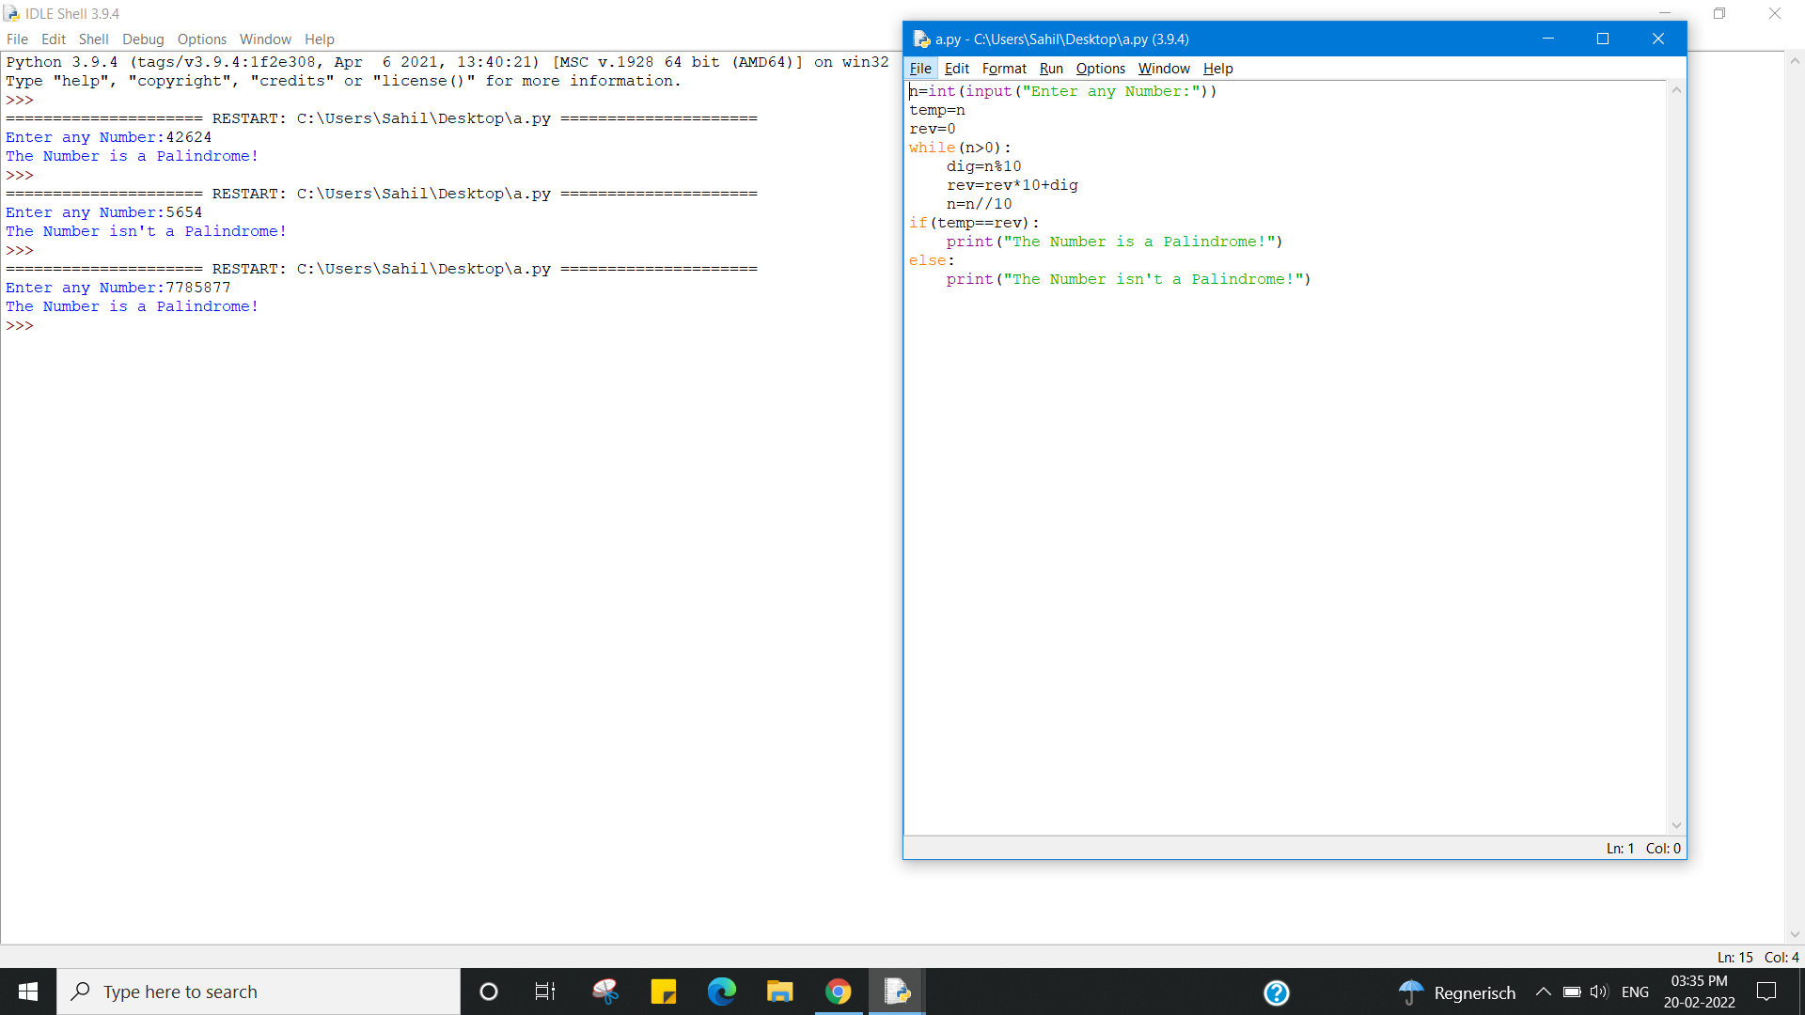

* Python Program to check Whether entered number is Armstrong or Not?

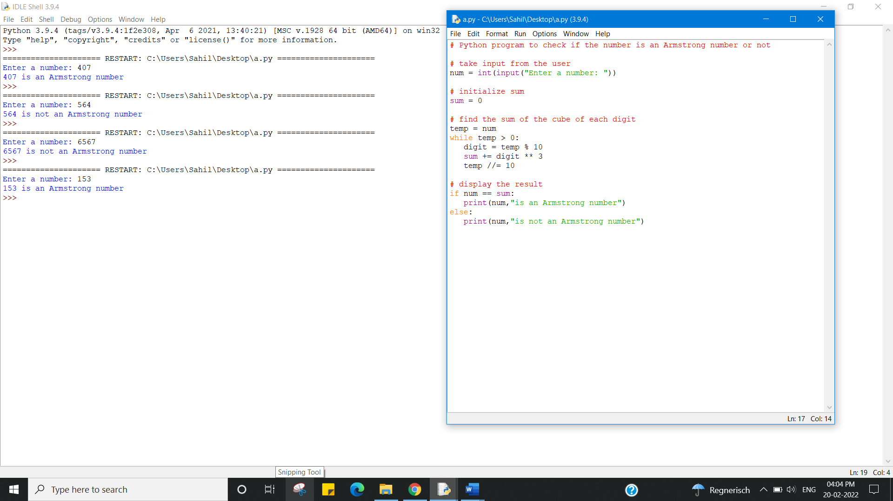

* Python Program to Take three numbers from the user and print the greatest number

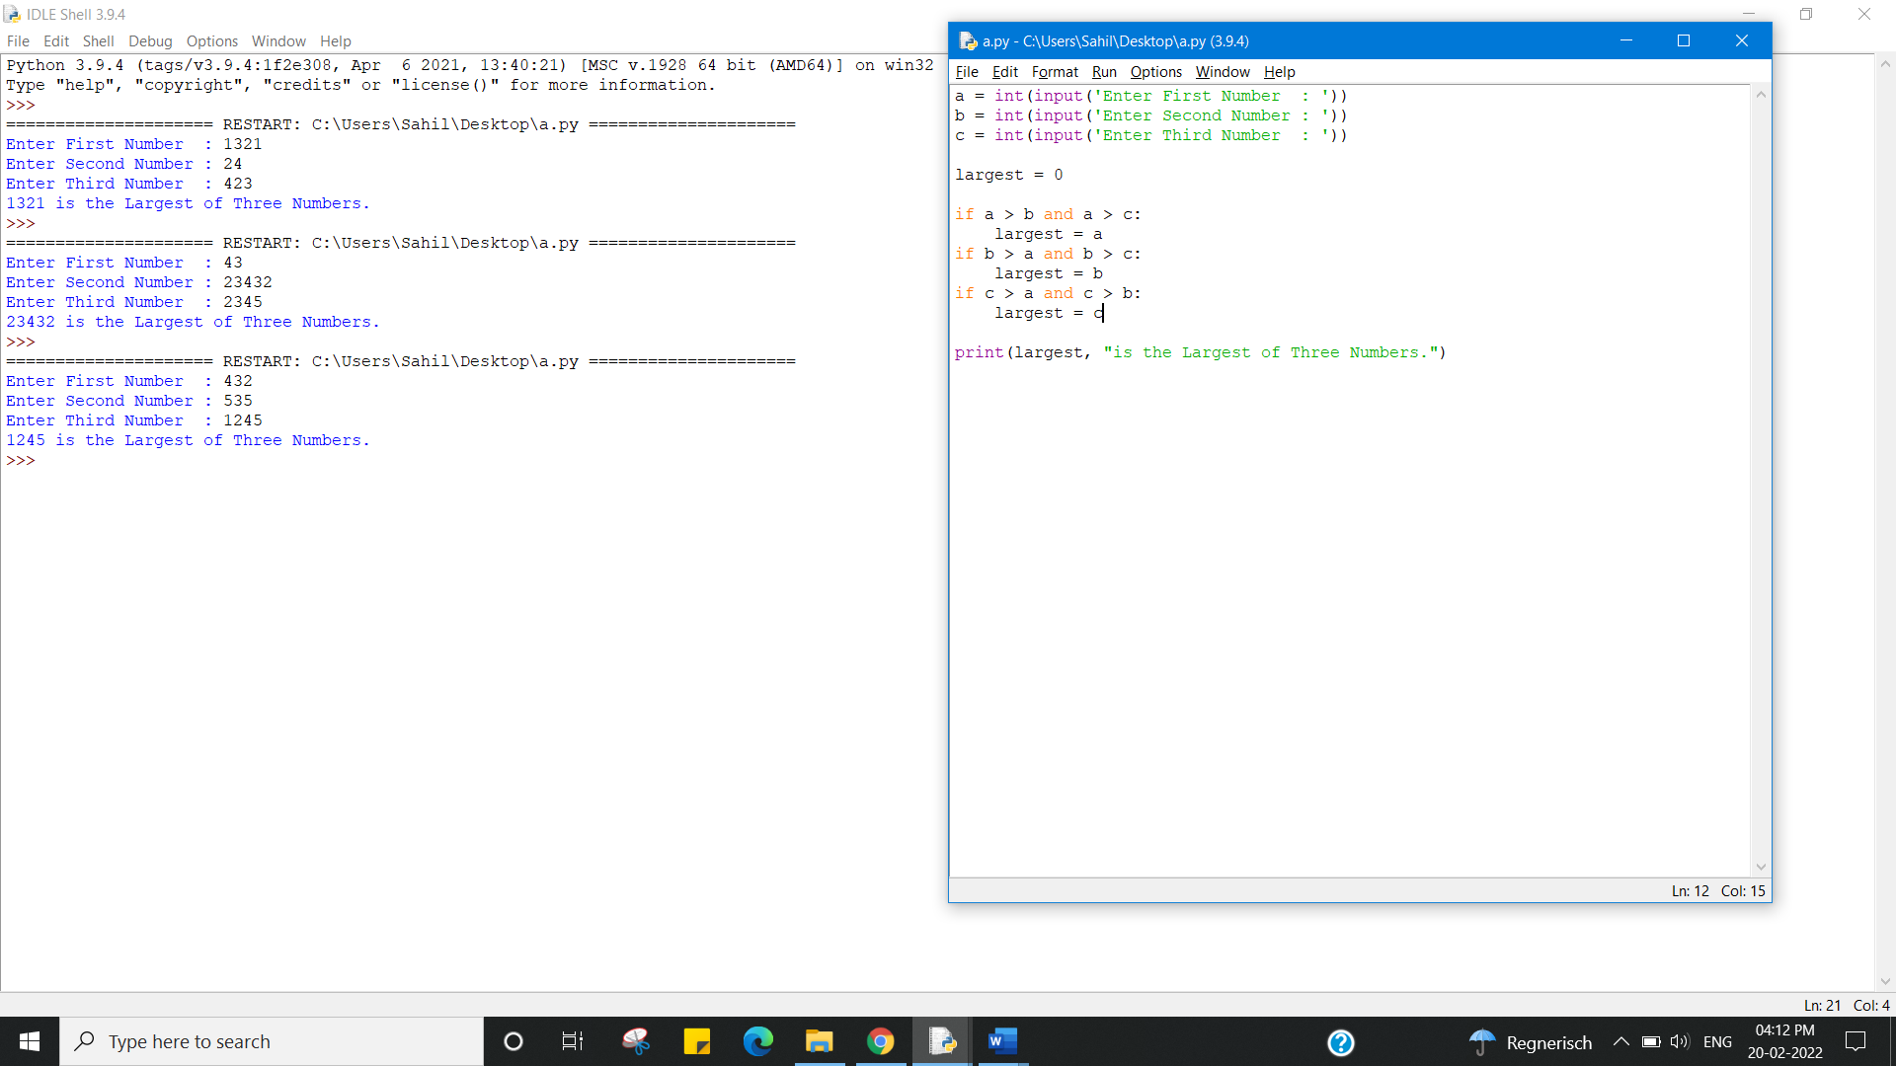

Learning outcomes (What I have learnt):

1. Python Program to check whether a given number is a palindrome.
2. Python Program to check Whether entered number is Armstrong or Not
3. Python Program to Take three numbers from the user and print the greatest number

Evaluation Grid (To be created as per the SOP and Assessment guidelines by the faculty):



|  |  |  |  |
| --- | --- | --- | --- |
| Sr. No. | Parameters | Marks Obtained | Maximum Marks |
| 1. |  |  |  |
| 2. |  |  |  |
| 3. |  |  |  |
|  |  |  |  |